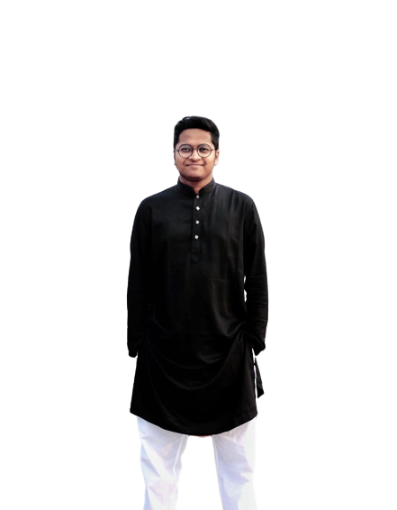

**CURRICULUM VITAE**

# Md. Al Adnan

Contact No: 01625208031

E-mail: [adnan2513@student.nstu.edu.com](mailto:adnan2513@student.nstu.edu.com)

Address: Mohammadpur-Dhaka

GitHub : <https://github.com/aladnansami>

LinkedIn: <https://www.linkedin.com/in/aladnansami/>

Facebook: <https://www.facebook.com/al.adnan.18>

## CAREER OBJECTIVE

I am a self-motivated professional passionate about quality control and Software Automation. I bring to this position a hands-on approach in the testing of software systems. I have a solid understanding of QA methodologies used in the industry and the Software Development Life Cycle (SDLC). I have 1 years of work-related experience in Quality assurance and Automation. My areas of expertise extend to cover Test Plans and Test Cases Development, Configuration and Troubleshooting.

## W O R K EXPERIENCE

1. **Kona Software Lab Limited (**March 2022- December-2022**)**

**Position :** Software Engineer Trainee

**Location :** Police Plaza Concord Tower, Gulshan-1, Dhaka-Bangladesh

**ID :** KSL202253

## PROJECTS

* **Dmoney API Testing (Using Postman)**

( https://github.com/aladnansami/Demoney_Postman_API_Testing)

* **Books API Load Testing (Using JMETER)**

( https://github.com/aladnansami/Book-API-Load-Test )

* **EMI-Calculator-Android-Apps-Automation (Using-Appium)**

( https://github.com/aladnansami/EMI-Calculator-Android-Apps-Automation-using-Appium)

* **Ecommerce website automation (Using TestNG and allure reports)**

( https://github.com/aladnansami/Ecomerce-Website-Automation-Using-TestNG-)

* **Rest Assured API Testing**

( https://github.com/aladnansami/Rest-Assured-Api-Testing)

* **Cypress E2E automation**

( https://github.com/aladnansami/Cypress-E2E-Automation-)

* **Flappy Birds(Java Swing Project)**

(<https://github.com/aladnansami/Flappy-Birds-Game>)

* **Restaurant Management System(Web Technology Project)**

( <https://github.com/aladnansami/Online-restaurent-management-system>)

* **NSTU Bus Tracking System(Android Project) (**<https://github.com/aladnansami/NSTU-Bus-Tracking-System>) & so on.

## TECHNICAL SKILLS

* **Programming Language**  (C, Java)
* **Manual Testing**: Requirement Analysis, Test Designing and Planning, Test Case Writing, Test Evaluation and Execution, System Testing, Regression Testing, Usability testing, UI Testing.
* **Web Automation Testing Tools** : JUnit, TestNG.
* **Api Testing Tools** : Postman, Newman.
* **Performance Testing Tools** : JMeter
* **Web Languages** (HTML5, CSS, PHP )
* **Testing Tools** (JMeter, Postman, Selenium )
* **Testing Methodology** (Agile methodology)
* **Database** (MySQL,MongoDB)
* **Office Tools** (MS Office, MS Powerpoint, MS Excel)
* **IDE** (Intellij IDEA, VSCode)
* **Version Control**  (GitHub, GitLab, Git, Jira)

## EDUCATIONAL QUALIFICATION

1. **BACHELOR OF SCIENCE AND SOFTWARE ENGINEERING**

University : Noakhali Science And Technology University Passing Year : February 2023

Result : 3.56(current) out of 4

## HIGHER SECONDARY SCHOOL CERTIFICATE

Institute : Brahmanbaria Govt. College,Brahmanbaria

Group : Science

Board : Comilla

Passing Year 2016

Result : 4.75(A) out of 5

## SECONDARY SCHOOL CERTIFICATE

Institute : Brahmanbaria High School , Brahmanbaria Group : Science

Board : Comilla

Passing Year 2014

Result : 5(A+) out of 5

## INTEREST

* Software Development Engineering in Test
* Automation Engineer

## LANGUAGE SKILLS

* Bangla
* English

## CERTIFICATIONS

## Software Development Engineering in Test

**Institute :** Road To SDET

**Location :** Online Platforms

**Duration :** 70+ hours

**Year** 2022

## Web Design And Development Course.

**Institute :** Institute of Information Technology,NSTU **Location :** NSTU Campus,Noakhali, Bangladesh

**Duration :** 3 Month

**Year** 2018

## EXTRA CO CURRICULAR ACTIVITIES

* **Convener**-BASIS Student’s Forum-NSTU Chapter ([BASIS Students Forum-NSTU Chapter | Facebook](https://www.facebook.com/basisstudentsforumnstu))
* **District Coordinator**- NASA Space APPS Challenge Bangladesh Chittagong Division.
* **Former Convener**- IT Club ,NSTU([IT_Club NSTU | Facebook](https://www.facebook.com/ITClubNSTU))
* **Class Representative** – Institute of information technology (SE01),NSTU
* **IT Member** – Unicef Bangladesh

## REFERENCE

|  |  |
| --- | --- |
| **Md Ariful Islam Foysal**  Sr. Automation Engineer  Kona Software Lab Ltd  Cell: 8801521204662  Relation: Colleague | **Salman Rahman**  Software Automation Professional  Sr. Software Engineer - CEFALO  Instructor – Road To SDET  Cell: 01686606909  Relation: Mentor |